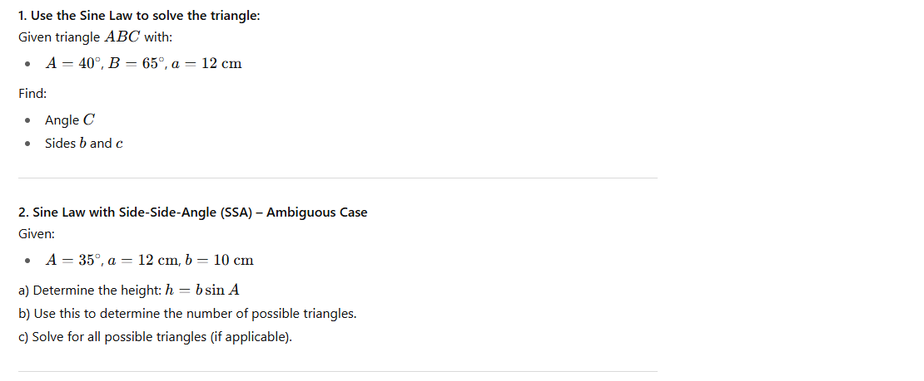Name: ________________________ Assignment 1: Sine Law

